**1.Create a Bucket in IBM object storage.**

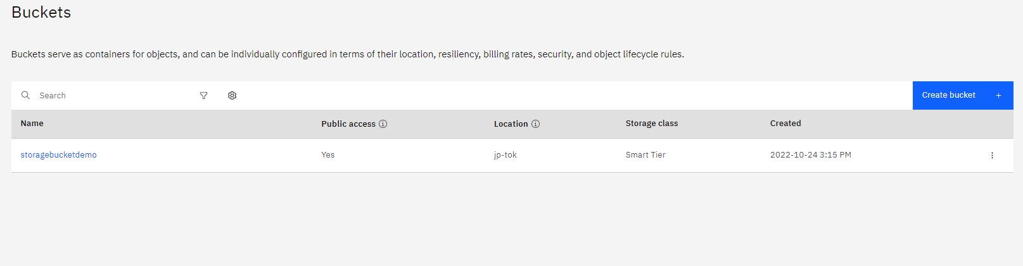

**2.Upload an 5 images to ibm object storage and make it public. write html code to displaying all the 5 images.**

**3.Upload a css page to the object storage and use the same page in your HTML code.**

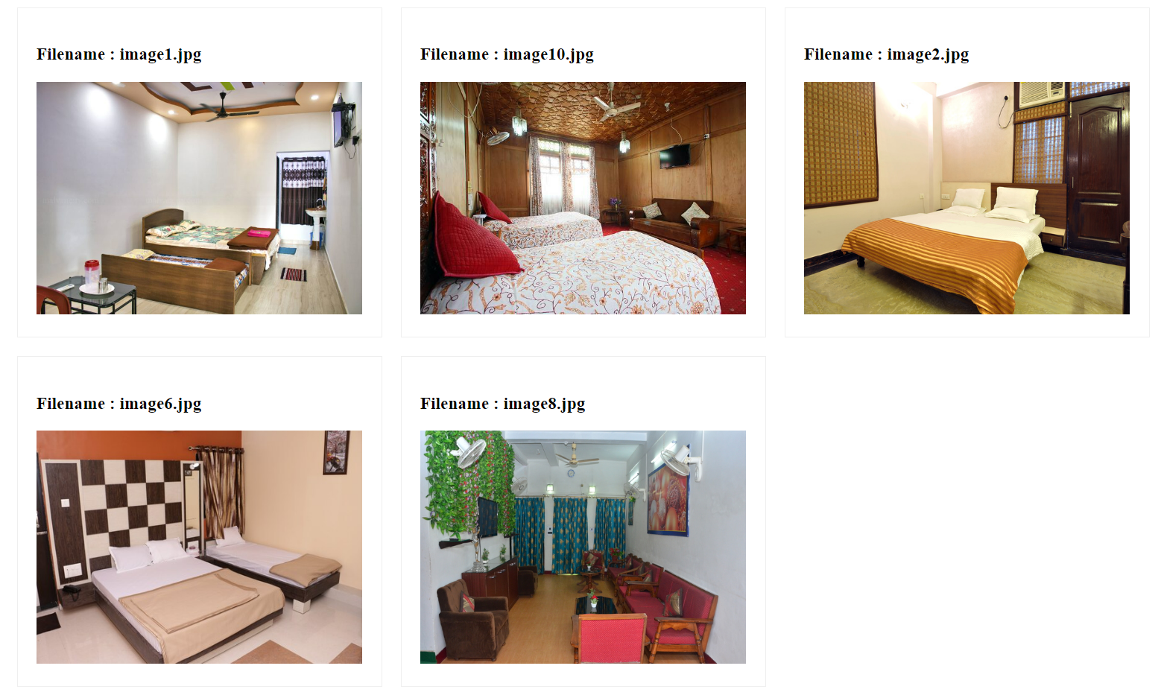

**4.Design a chatbot using IBM Watson assistant for hospital. Ex: User comes with query to know the branches for that hospital in your city. Submit the web URL of that chat bot as an assignment.**

[Chatbot Link](https://web-chat.global.assistant.watson.appdomain.cloud/preview.html?backgroundImageURL=https%3A%2F%2Fus-south.assistant.watson.cloud.ibm.com%2Fpublic%2Fimages%2Fupx-55697895-7d4b-4355-9b55-0ad5d4ab9e5f%3A%3Aa9863d92-c7fb-4de6-ab8b-c2418c798c41&integrationID=8f0c0e35-4fce-457a-a812-53608c69334a&region=us-south&serviceInstanceID=55697895-7d4b-4355-9b55-0ad5d4ab9e5f)

**5.Create Watson assistant service with 10 steps and use 3 conditions in it. Load that script in HTML page. (Watson.html)**

